附件一：

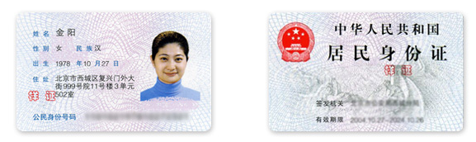

个人联系方式：135××××××××

个人签名：

附件二：

**×××单位人员信息汇总表**

|  |  |  |  |
| --- | --- | --- | --- |
| 序号 | 姓名 | 身份证号码 | 本人确认签字 |
|  |  |  |  |
|  |  |  |  |
|  |  |  |  |
|  |  |  |  |
|  |  |  |  |
|  |  |  |  |
|  |  |  |  |
|  |  |  |  |
|  |  |  |  |
|  |  |  |  |
|  |  |  |  |
|  |  |  |  |
|  |  |  |  |
|  |  |  |  |
|  |  |  |  |
|  |  |  |  |
|  |  |  |  |
|  |  |  |  |
|  |  |  |  |
|  |  |  |  |